Newman Electric

Newman Electric
Generators starting as low as $TBD!!!

Generator Information
846 William Drive
Brielle, NJ 08730
Phone: 732.528.1918
Fax:

Image | Type | Details | Price
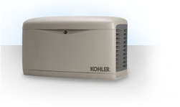 | Kohler | - Restores power within 10 seconds of going out  - Automatic operation  - Liquid Petroleum and Natural Gas options  - Range 8.5 to 100kW | $TBD to $TBD
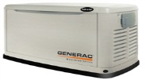 | Generac | - Whole house or critical circuit coverage available  - Generator specific engine design for longer life  - 4 different product lines available for specific needs  - Range 8kW to 50Hz | $TBD to $TBD
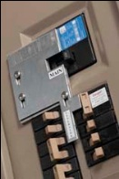 | InterLock Kit | - Quick and easy installation  - Safely feeds panel  - Do not take up additional wall space  - Meets all NEC requirements | $TBD to $TBD
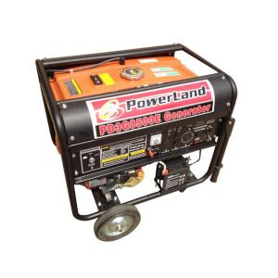 | Portable Natural Gas | - 4,400-10,000 Watt options available  - Available with Tri-Fuel feature (propane, natural gas, and gasoline)  - Longer runtime with more fuel options available.  - Electric start and battery | $TBD to $TBD
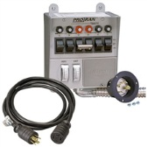 | Transfer Switches | - Available from 15A manual up to 800A automatic  - Up to 10 total circuits  - Safe and easy to use  - Wattage meter built in | $TBD to $TBD
Each generator is offered in a number of different sizes and capable of a wide variety of capacities. We can customize orders based on specific needs, and intended load size. Please contact us with any inquires and we will help you find the best option that fits your needs.

We’ve got what you need!

Douglas R. Newman Electric, Inc.
License #
Brielle, NJ 08730
732.528.1918

E-mail: douglas.r.newman@gmail.com

www.newman-electric.com

